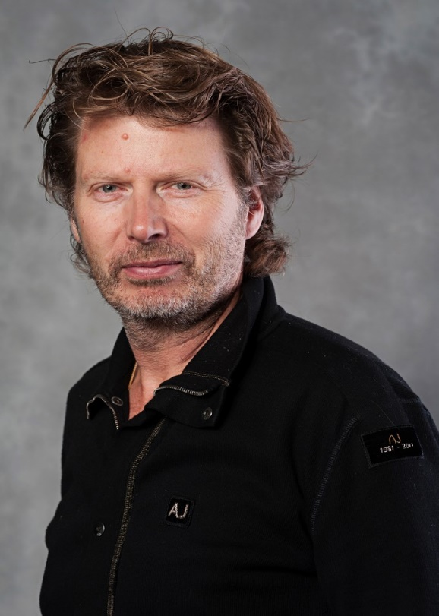
Professor, Vice President Håkan Wiklund, Mid Sweden University
Dr. Håkan Wiklund is currently professor in Quality Technology and Management at Mid Sweden University, Sweden. He received his PhD in Production Engineering at Linköping University and he became professor in Quality Technology and Management at Luleå University of Technology almost 20 years ago. Today he is deputy vice chancellor at Mid Sweden University where he also has been vice rector. He has been engaged as expert by the Swedish Higher Education Authority in many institutional reviews of quality assurance processes. He has also been engaged in international quality audits of universities and in international expert panels evaluating research. Furthermore, he has led the design of a joint and collegial based system for evaluating all education and postgraduate education at three Swedish universities.

